**Lab – 5**

**MapReduce Programming using Python**

**MapReduce**: **Programming Model and Implementations:**

Hadoop is a framework that allows to process and store huge data sets. Basically, Hadoop can be divided into two parts: processing and storage. So, MapReduce is a programming model which allows you to process huge data stored in Hadoop. When you install Hadoop in a cluster, we get MapReduce as a service where you can write programs to perform computations in data in parallel and distributed fashion.

**Map – Reduce Implementation:**

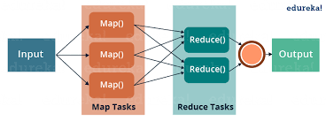

MapReduce is a programming framework that allows us to perform distributed and parallel processing on large data sets in a distributed environment. MapReduce consists of two distinct tasks – Map and Reduce. As the name MapReduce suggests, reducer phase takes place after mapper phase has been completed. So, the first is the map job, where a block of data is read and processed to produce key-value pairs as intermediate outputs. The output of a Mapper or map job (key-value pairs) is input to the Reducer. The reducer receives the key-value pair from multiple map jobs. Then, the reducer aggregates those intermediate data tuples (intermediate key-value pair) into a smaller set of tuples or key-value pairs which is the final output.

**Execution:**

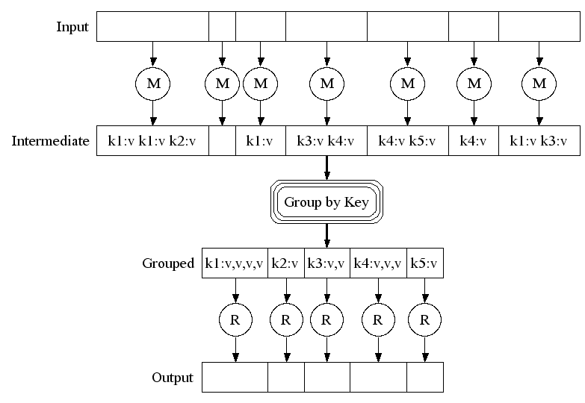

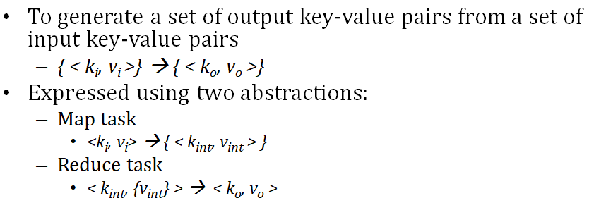

**The Wordcount Example**

The Wordcount application counts the number of occurrences of each word in a large collection of documents.

The steps of the process are briefly described as follows:

* The input is read and broken up into key/value pairs (e.g., the Map function emits a word and its associated count of occurrence, which is just “1”).
* The pairs are partitioned into groups for processing, and they are sorted according to their key as they arrive for reduction.
* Finally, the key/value pairs are reduced, once for each unique key in the sorted list, to produce a combined result (e.g., the Reduce function sums all the counts emitted for a particular word).

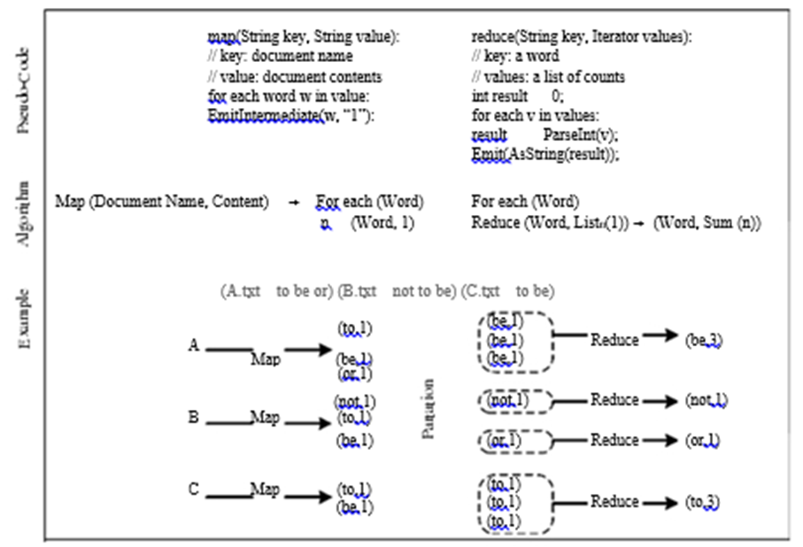

**Another Example:**

map(String input_key, String input_value):

// input_key: document name

// input_value: document contents

for each word w in input_value:

EmitIntermediate(w, "1");

reduce(String output_key, Iterator intermediate_values):

// output_key: a wo <“Sam” , [“1”,”1”,”1”]>, <“Apple” , [“1”]>, <“Mom” , [“1”, “1”] >

// output_values: a list of counts

int result = 0;

for each v in intermediate_values:

result += ParseInt(v);

Emit(AsString(result));

<“Sam”, “1”>, <“Apple”, “1”>, <“Sam”, “1”>, <“Mom”, “1”>, <“Sam”, “1”>, <“Mom”, “1”>,

“3”

“1”

“2”

**1. Write a basic wordcount program.**

**Sample Pseudocode:**

**Mapper:**

void Map (key, value)

{

for each word x in value:

emit(x, 1);

}

**Reducer:**

void Reduce (keyword, <list_val>)

{

for each x in <list_val>:

sum+=x;

emit(keyword, sum);

}

**Python Programs:**

*#!/usr/bin/env python*

"""mapper.py"""

import sys

*# input comes from STDIN (standard input)*

**for** line **in** sys**.**stdin:

*# remove leading and trailing whitespace*

line **=** line**.**strip()

*# split the line into words*

words **=** line**.**split()

*# increase counters*

**for** word **in** words:

*# write the results to STDOUT (standard output);*

*# what we output here will be the input for the*

*# Reduce step, i.e. the input for reducer.py*

*#*

*# tab-delimited; the trivial word count is 1*

**print** '%s\t%s' **%** (word, 1)

*#!/usr/bin/env python*

"""reducer.py"""

from operator import itemgetter

import sys

current_word **=** None

current_count **=** 0

word **=** None

*# input comes from STDIN*

**for** line **in** sys**.**stdin:

*# remove leading and trailing whitespace*

line **=** line**.**strip()

*# parse the input we got from mapper.py*

word, count **=** line**.**split('\t', 1)

*# convert count (currently a string) to int*

**try**:

count **=** int(count)

**except** ValueError:

*# count was not a number, so silently*

*# ignore/discard this line*

**continue**

*# this IF-switch only works because Hadoop sorts map output*

*# by key (here: word) before it is passed to the reducer*

**if** current_word **==** word:

current_count **+=** count

**else**:

**if** current_word:

*# write result to STDOUT*

**print** '%s\t%s' **%** (current_word, current_count)

current_count **=** count

current_word **=** word

*# do not forget to output the last word if needed!*

**if** current_word **==** word:

**print** '%s\t%s' **%** (current_word, current_count)

**Test your code locally**:

*# Test mapper.py and reducer.py locally first*

*# very basic test (using only mapper.py)*

[hduser@ubuntu](mailto:hduser@ubuntu):~$ echo "a a a a v v f f hh hh fg tg fg gt nnn ccc ddd nnn ddd"|python3 mapper.py

a 1

a 1

a 1

a 1

v 1

v 1

f 1

f 1

hh 1

hh 1

fg 1

tg 1

fg 1

gt 1

nnn 1

ccc 1

ddd 1

nnn 1

ddd 1

*# very basic test (using mapper.py and reducer.py)*

[hduser@ubuntu](mailto:hduser@ubuntu):~$ echo "a a a a v v f f hh hh fg tg fg gt nnn ccc ddd nnn ddd"|python3 mapper.py|python3 reducer.py

a 4

v 2

f 2

hh 2

fg 1

tg 1

fg 1

gt 1

nnn 1

ccc 1

ddd 1

nnn 1

ddd 1

*# very basic test (use mapper.py , sort the output and use reducer.py)*

[hduser@ubuntu](mailto:hduser@ubuntu):~$ echo "a a a a v v f f hh hh fg tg fg gt nnn ccc ddd nnn ddd"|python3 mapper.py|sort|python3 reducer.py

a 4

ccc 1

ddd 2

f 2

fg 2

gt 1

hh 2

nnn 2

tg 1

v 2

*# very basic test (use mapper.py , sort the output and use reducer.py) and write it to text file)*

[hduser@ubuntu](mailto:hduser@ubuntu):~$ echo "a a a a v v f f hh hh fg tg fg gt nnn ccc ddd nnn ddd"|python3 mapper.py|sort|python3 reducer.py > out.txt

[hduser@ubuntu](mailto:hduser@ubuntu):~$ cat out.txt

To extract words from any dataset or any file…. (use the proper path of file in the command)

[hduser@ubuntu](mailto:hduser@ubuntu):~$ cat /home/xxx/Desktop/HR.txt | python3 mapper.py | sort | python3 reducer.py > out_HR.txt

[s](mailto:shanthi@shanthi)[hduser@ubuntu](mailto:hduser@ubuntu):~$ cat out_HR.txt

**Exercise 1: Try the above word count program for the Heart Disease dataset, covid_19_data dataset, example dataset and German Credit dataset.**

**Students can decide their own way of displaying results (can work on any columns in the dataset ) on the dataset mentioned.**

**_____________________________________________________________________________**

**2. MapReduce program to find frequent words**

freqmap1.py

*#!/usr/bin/env python*

*# A basic mapper function/program that*

*# takes whatever is passed on the input and*

*# outputs tuples of all the words formatted*

*# as (word, 1)*

**from** **__future__** **import** print_function

**import** **sys**

*# input comes from STDIN (standard input)*

**for** line **in** sys.stdin:

*# create tuples of all words in line*

L = [ (word.strip().lower(), 1 ) **for** word **in** line.strip().split() ]

*# increase counters*

**for** word, n **in** L:

*# write the results to STDOUT (standard output);*

*# what we output here will be the input for the*

*# Reduce step, i.e. the input for reducer.py*

*#*

*# tab-delimited; the trivial word count is 1*

**print**( '**%s\t%d**' % (word, n) )

freqred1.py

*#!/usr/bin/env python*

*# reducer.py*

**from** **__future__** **import** print_function

**import** **sys**

lastWord = None

sum = 0

**for** line **in** sys.stdin:

word, count = line.strip().split('**\t**', 1)

count = int(count)

**if** lastWord==None:

lastWord = word

sum = count

**continue**

**if** word==lastWord:

sum += count

**else**:

**print**( "**%s\t%d**" % ( lastWord, sum ) )

sum = count

lastWord = word

*# output last word*

**if** lastWord == word:

**print**( '**%s\t%s**' % (lastWord, sum ) )

freqmap2.py

*#!/usr/bin/env python*

*# A basic mapper function/program that*

*# takes whatever is passed on the input and*

*# outputs tuples of all the words formatted*

*# as (word, 1)*

**from** **__future__** **import** print_function

**import** **sys**

*# input comes from STDIN (standard input)*

**for** line **in** sys.stdin:

word, count = line.strip().split('**\t**', 1)

count = int(count)

**print**( '**%d\t%s**' % (count, word) )

freqred2.py

*#!/usr/bin/env python*

*# reducer.py*

**from** **__future__** **import** print_function

**import** **sys**

mostFreq = []

currentMax = -1

**for** line **in** sys.stdin:

count, word = line.strip().split('**\t**', 1)

count = int(count)

**if** count > currentMax:

currentMax = count

mostFreq = [ word ]

**elif** count == currentMax:

mostFreq.append( word )

*# output mostFreq word(s)*

**for word in mostFreq:**

**print( '%s\t%s' % ( word, currentMax ) )**

[hduser@ubuntu](mailto:hduser@ubuntu):~$ echo "foo foo foo labs labs labs quux labs foo bar quux" | python3 freqmap1.py |sort|python3 freqred1.py

bar 1

foo 4

labs 4

quux 2

[hduser@ubuntu](mailto:hduser@ubuntu):~$ echo "foo foo foo labs labs labs quux labs foo bar quux" | python3 freqmap1.py |sort|python3 freqred1.py|python3 freqmap2.py

1 bar

4 foo

4 labs

2 quux

[hduser@ubuntu](mailto:hduser@ubuntu):~$ echo "foo foo foo labs labs labs quux labs foo bar quux" | python3 freqmap1.py |sort|python3 freqred1.py|python3 freqmap2.py|sort

1 bar

2 quux

4 foo

4 labs

[hduser@ubuntu](mailto:hduser@ubuntu):~$ echo "foo foo foo labs labs labs quux labs foo bar quux" | python3 freqmap1.py |sort|python3 freqred1.py|python3 freqmap2.py|sort|python3 freqred2.py

foo 4

labs 4

**Exercise 2: Try the above frequent word count program for the Heart Disease dataset, covid_19_data dataset, example dataset and German Credit data.**

**Students can decide their own way of displaying results (can work on any columns in the dataset ) on the dataset mentioned.**

**________________________________________________________________________________**

**3. MapReduce program to explore the dataset and perform the** filtering **(typically creating key/value pairs) by mapper and perform the count and** summary operation **on the instances.**

**Itemmap.py**

**#!/usr/bin/python**

**"""**

INPUT: Transactions of products in multiple stores and location; these can also be passed to STDIN

Format of each line is: date\ttime\tstore location\titem description\tcost\tmethod of payment

OUTPUT: E.g.

Las Vegas 208.97

Miami 84.11

Tucson 489.93

San Francisco 388.3

Dallas 145.63

Tampa 353.23

Washington 481.31

San Jose 492.8

Newark 410.37

Memphis 354.44

Jersey City 369.07

Plano 4.65

Buffalo 337.35

Louisville 213.64

Miami 154.64

...

"""

#import string

**import fileinput**

**for line in fileinput.input():**

**data = line.strip().split("\t")**

**if len(data) == 6:**

**date, time, location, item, cost, payment = data**

**print ("{0}\t{1}".format(location, cost))**

#can try with different instances.....

#print ("{0}\t{1}".format(payment, cost))

#print ("{0}\t{1}".format(item, cost))

**itemred.py**

#!/usr/bin/python

"""

INPUT: Output from mapper.py

Format of each line is: location\tcost

OUTPUT: E.g.

50 12268.16

"""

**import fileinput**

**transactions_count = 0**

**sales_total = 0**

**for line in fileinput.input():**

**data = line.strip().split("\t")**

**if len(data) != 2:**

# Something has gone wrong. Skip this line.

**continue**

**current_key, current_value = data**

**transactions_count += 1**

**sales_total += float(current_value)**

**print (transactions_count, "\t", sales_total)**

**Mapper Output:**

[hduser@ubuntu](mailto:hduser@ubuntu): ~ $ cat /home/shanthi/Desktop/example.txt | python3 itemmap.py| sort

Atlanta 189.22

Aurora 82.38

Austin 48.09

Birmingham 1.64

Boston 397.21

Buffalo 337.35

Buffalo 386.56

Chicago 364.53

Chicago 431.73

Cincinnati 129.6

Cincinnati 1.41

Cincinnati 288.32

Cincinnati 443.78

Corpus Christi 157.91

…….

**Reducer Output:**

[hduser@ubuntu](mailto:hduser@ubuntu):~$ cat /home/shanthi/Desktop/example.txt | python3 itemmap.py |sort| python3 itemred.py

50 12268.159999999996 # displayed total instances and its sum

**Exercise 3: Try the above ‘Item explore and count program’ for the Heart Disease dataset, covid_19_data dataset, example dataset and German Credit dataset.**

**Students can decide their own way of displaying results (can work on any columns in the dataset ) on the dataset mentioned.**

**_____________________________________________________________________________**

**4. Write a mapper and reducer program for word count by defining separator instead of using “\t”.**

**sepmap.py**

**#**!/usr/bin/env python

"""A more advanced Mapper, using Python iterators and generators."""

**import sys**

**def read_input(file):**

**for line in file:**

# split the line into words

**yield line.split()**

**def main(separator='\t'):**

**#** input comes from STDIN (standard input)

**data = read_input(sys.stdin)**

**for words in data:**

**#** write the results to STDOUT (standard output);

# what we output here will be the input for the

# Reduce step, i.e. the input for reducer.py

# tab-delimited; the trivial word count is 1

**for word in words:**

**print ('%s%s%d' % (word, separator, 1))**

**if __name__ == "__main__":**

**main()**

**sepred.py**

**#!**/usr/bin/env python

"""A more advanced Reducer, using Python iterators and generators."""

**from itertools import groupby**

**from operator import itemgetter**

**import sys**

**def read_mapper_output(file, separator='\t'):**

**for line in file:**

**yield line.rstrip().split(separator, 1)**

**def main(separator='\t'):**

# input comes from STDIN (standard input)

**data = read_mapper_output(sys.stdin, separator=separator)**

# groupby groups multiple word-count pairs by word,

# and creates an iterator that returns consecutive keys and their group:

# current_word - string containing a word (the key)

# group - iterator yielding all ["&lt;current_word&gt;", "&lt;count&gt;"] items

**for current_word, group in groupby(data, itemgetter(0)):**

**try:**

**total_count = sum(int(count) for current_word, count in group)**

**print ("%s%s%d" % (current_word, separator, total_count))**

**except ValueError:**

# count was not a number, so silently discard this item

**pass**

**if __name__ == "__main__":**

**main()**

**Note:**

**Why Separator ?**

**Eg:**

print('G','F', sep='', end='')print('G')

#\n provides new line after printing the year

print('09','12','2016', sep= '-', end='\n')

print('prtk','agarwal', sep= ' ' , end='@')

print('manipal')

Output:

GFG

09-12-2016

[prtkagarwal@manipal](mailto:prtkagarwal@manipal)

Output:

[hduser@ubuntu](mailto:hduser@ubuntu):~$ echo " Time is gold Time is Time gold" | python3 sepmap.py|python3 sepred.py

Time ->1

is ->1

gold ->1

Time ->1

is ->1

Time ->1

gold ->1

[hduser@ubuntu](mailto:hduser@ubuntu):~$ echo " Time is gold Time is Time gold" | python3 sepmap.py|sort|python3 sepred.py

gold ->2

is ->2

Time →3

**Exercise 4: Try to include separator using map reducing for the output of Heart Disease dataset, covid_19_data dataset, example dataset and German Credit dataset.**

**________________________________________________________________________________**

5. Write a map reduce program that returns the cost of the item that is most expensive, for each location in the dataset example.txt

**itemmap_expensive.py**

#!/usr/bin/python

“""

INPUT: Transactions of products in multiple stores and location; these can also be passed to STDIN

Format of each line is: date\ttime\tstore location\titem description\tcost\tmethod of payment

OUTPUT: E.g.

Las Vegas 208.97

Miami 84.11

Tucson 489.93

San Francisco 388.3

Dallas 145.63

Tampa 353.23

Washington 481.31

San Jose 492.8

Newark 410.37

Memphis 354.44

Jersey City 369.07

Plano 4.65

Buffalo 337.35

Louisville 213.64

Miami 154.64

...

"""

import fileinput

for line in fileinput.input():

data = line.strip().split("\t")

if len(data) == 6:

date, time, location, item, cost, payment = data

print ("{0}\t{1}".format(location, cost))

**itemred_expensive.py**

#!/usr/bin/python

"""

INPUT: Output from mapper.py

Format of each line is: location\tcost

OUTPUT: E.g.

Atlanta 189.22

Aurora 82.38

Austin 48.09

Birmingham 1.64

Boston 397.21

Buffalo 386.56

"""

import fileinput

max_value = 0

old_key = None

for line in fileinput.input():

data = line.strip().split("\t")

if len(data) != 2:

**# Something has gone wrong. Skip this line.**

continue

current_key, current_value = data

**# Refresh for new keys (i.e. locations in the example context)**

if old_key and old_key != current_key:

print (old_key, "\t", max_value)

old_key = current_key

max_value = 0

old_key = current_key

if float(current_value) > float(max_value):

max_value = float(current_value)

if old_key != None:

print (old_key, "\t", max_value)

Output:

[hduser@ubuntu](mailto:hduser@ubuntu):~$ cat /home/shanthi/Desktop/example.txt | python3 itemmap1.py|sort

Atlanta 189.22

Aurora 82.38

Austin 48.09

Birmingham 1.64

Boston 397.21

Buffalo 337.35

Buffalo 386.56 # selects max value

Chicago 364.53

Chicago 431.73 …… # selects max value

[hduser@ubuntu](mailto:hduser@ubuntu):~$ cat /home/shanthi/Desktop/example.txt | python3 itemmap1.py|sort|python3 itemred1.py

Atlanta 189.22

Aurora 82.38

Austin 48.09

Birmingham 1.64

Boston 397.21

Buffalo 386.56 # selected max value

Chicago 431.73 # selected max value

**Exercise 5: Try to apply finding max value using map reduce concept for the output of Heart Disease dataset, covid_19_data dataset, example dataset and German Credit dataset.**

**Students can decide their own way of displaying results (can work on any columns in the dataset ) on the dataset mentioned.**

______________________________________________________________________________

6. Write a mapreduce program to evaluate the PI.

**mapper_pi.py**

*!/usr/bin/env python*

**import** **sys**

**def** f( x ):

**return** 4.0 / ( 1.0 + x*x )

*# input comes from STDIN (standard input)*

**for** line **in** sys.stdin:

*# remove leading and trailing whitespace*

line = line.strip()

*# split the line into words*

words = line.split()

N = int( words[0] )

deltaX = 1.0 / N

**for** i **in** range( 0, N ):

**print**( "1**\t%1.10f**" % ( f( i * deltaX )*deltaX ) )

## reducer_pi.py

*#!/usr/bin/env python*

**from** **__future__** **import** print_function

**from** **operator** **import** itemgetter

**import** **sys**

sum = 0

*# input comes from STDIN*

**for** line **in** sys.stdin:

*# remove leading and trailing whitespace*

line = line.strip()

*# parse the input we got from mapper.py*

word, count = line.split('**\t**', 1)

*# convert count (currently a string) to int*

**try**:

count = float(count)

**except** **ValueError**:

*# count was not a number, so silently*

*# ignore/discard this line*

*#print( "--skipping (%s, %s)" % ( str(word), str(count) ) )*

**continue**

sum += count

*# do not forget to output the last word if needed!*

**print**( '**%1.10f\t**0' % sum )

[**hduser@ubuntu**](mailto:hduser@ubuntu)**:~$ echo "5" | python3 pimap.py**

**1 0.8000000000**

**1 0.7692307692**

**1 0.6896551724**

**1 0.5882352941**

**1 0.4878048780**

**shanthi@shanthi:~$ echo "5" | python3 pimap.py|python3 pired.py**

**3.3349261137 0**

[**hduser@ubuntu**](mailto:hduser@ubuntu)**:~$ echo "3" | python3 pimap.py**

**1 1.3333333333**

**1 1.2000000000**

**1 0.9230769231**

[**hduser@ubuntu**](mailto:hduser@ubuntu)**:~$ echo "3" | python3 pimap.py|python3 pired.py**

**3.4564102564 0**

**Exercise 6: Write a MapReduce Program to evaluate value of pi**

**Exercise 7: Write a MapReduce program to generate a report with Number of males, females and total births in each year, number of males, females and total births in each month of a particular year from national birth data.**

**Exercise 8: Write a MapReduce program to count even or odd numbers in randomly generated natural numbers**

**\*\*\*\*\*\*\*\*\*\*\*\*\*\*\*\*\*\*\*\*\*\*\*\*\*\*\*\*\*\*\*\*\*\*\*All The Best \*\*\*\*\*\*\*\*\*\*\*\*\*\*\*\*\*\*\*\*\*\*\*\*\*\*\*\*\*\*\*\*\*\***